Advance Cyber Security Serial No 09

Assignment 2

shreyyash

2020

March

Contents

1. Assignment 2: Virtual Machine 3
   1. Answer 1………………..…………………………. 3
   2. Answer 2………….…….…………………………. 4

List of figures

1.3.1 Figure 1: Base machine IP in bridge mode ……………..…………. 4

1.3.1 Figure 2: Kali machine IP in bridge mode……………….……......... 4

1.3.1 Figure 3: Kali machine Internet and Base ping in bridge mode…… 5

1.3.1 Figure 4: Kali machine Metasploitable ping in bridge mode………. 5

1.3.2 Figure 5: Kali machine IP in NAT mode…………………………… 5

1.3.2 Figure 6: Kali machine Ping in NAT mode………………………… 5

1.3.3 Figure 6: Kali machine IP in Host Only mode……………………… 5

CHAPTER 2

Assignment 2: Virtual Machine

* 1. Introduction

The base machine used for assignment is Parrot. Kali and Metasploitable machines have been made virtually using Virtual Box software.

* 1. Answer 1

1.2.1 Bridged Mode

In this mode of working, the virtual machines connect directly to the network interface of the base machine. They act as a separate machine with the same privileges of the base machine. The address allotted is in the same subnet as that of the base machine.

1.2.2 NAT

NAT stands for Network Address Translation. In this mode of working, the virtual machine’s NAT machine which assigns the virtual machine an IP. Through the IP allotted, the virtual machine connects to the base and outside environment. The virtual hosts are isolated in this mode.

1.2.3 Host Only

This mode restricts the network of the virtual machines to the base machine only. The virtual machines can ping each other, the base machine and vice-versa. However, the network access is not given to the virtual machines.

1.2.4 Kali Attacker to Virtual Machine

In this scenario, Host Only mode will be preferred since it allows the attacker to reach target with least privilege level.

1.2.5 Attacker and Victim in same Virtualised Environment

In this scenario also, we will prefer Host Only mode as it gets the job done with least priveleges.

1.3 Answer 2

1.3.1 Snapshots Bridged Mode

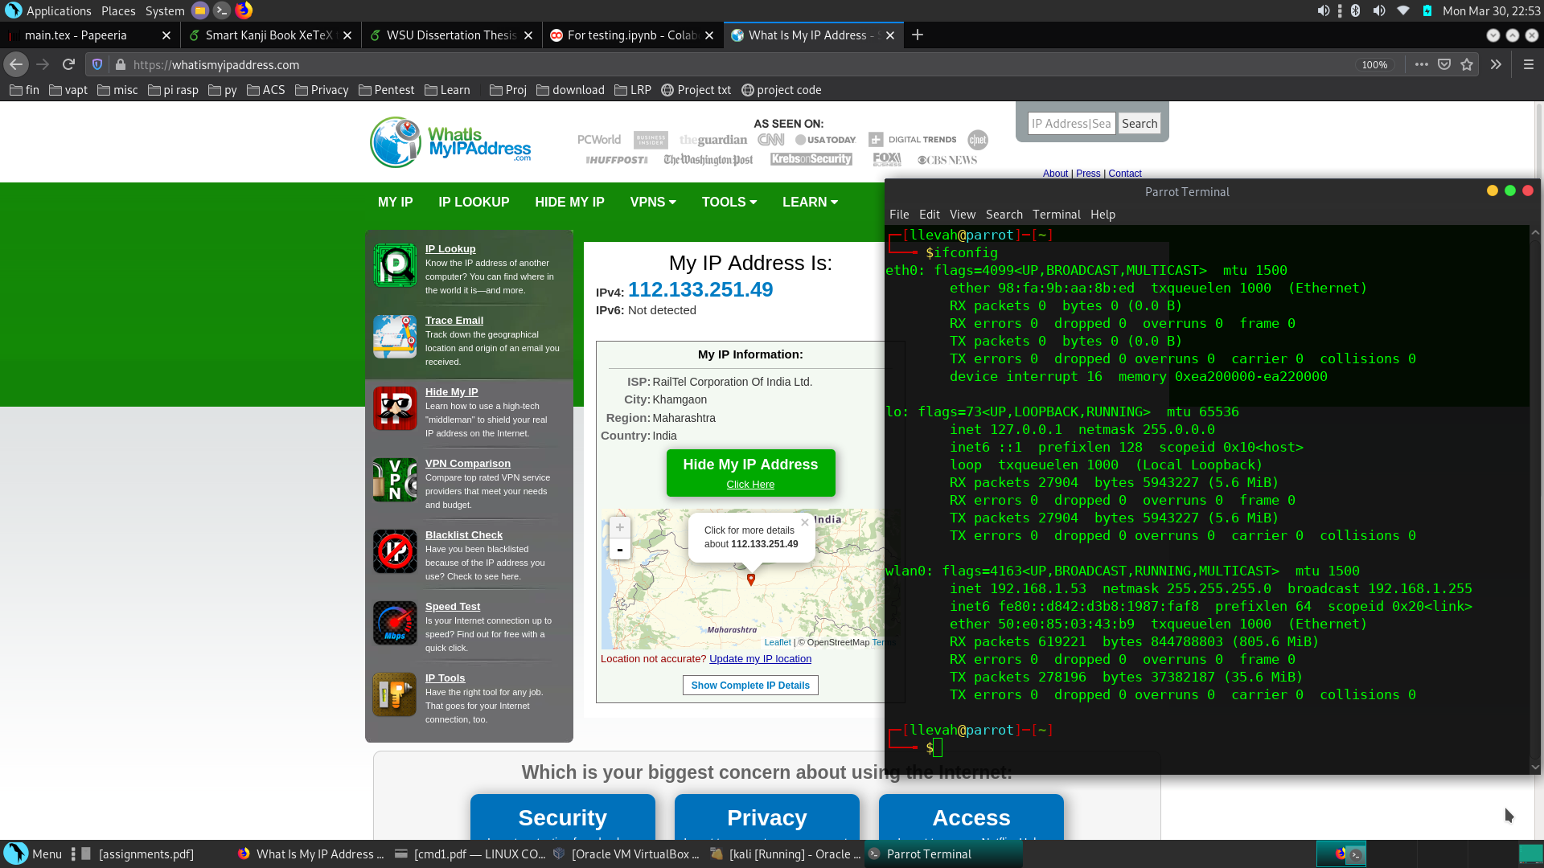

*Figure 1: Base machine IP in bridge mode*

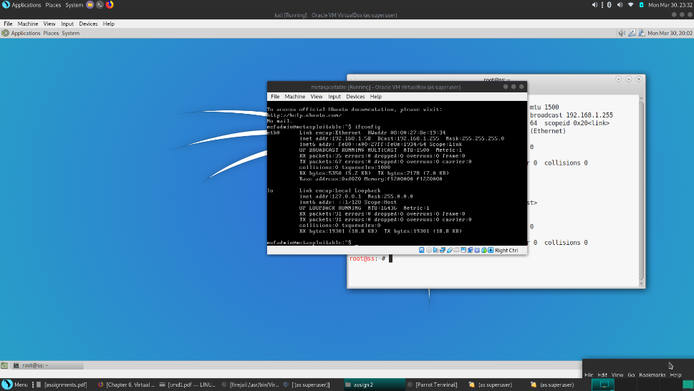

*Figure 2: Kali machine IP in bridge mode*

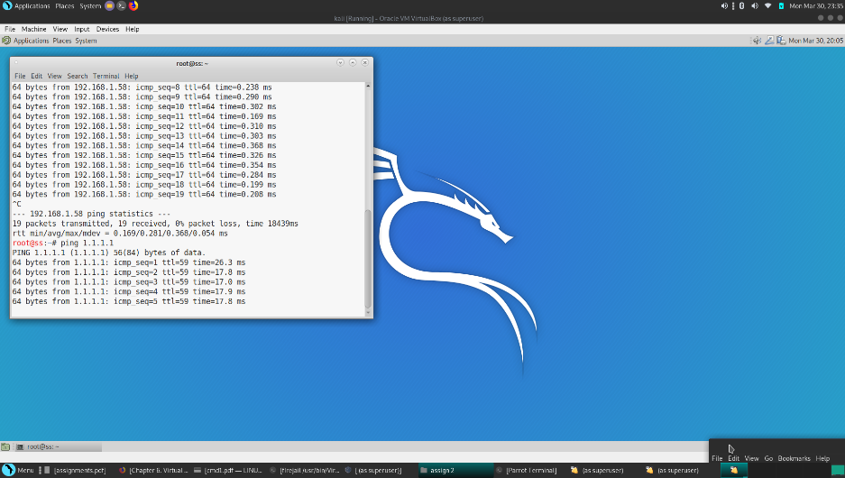

*Figure 3: Kali machine Internet and Base machine ping in bridge mode*

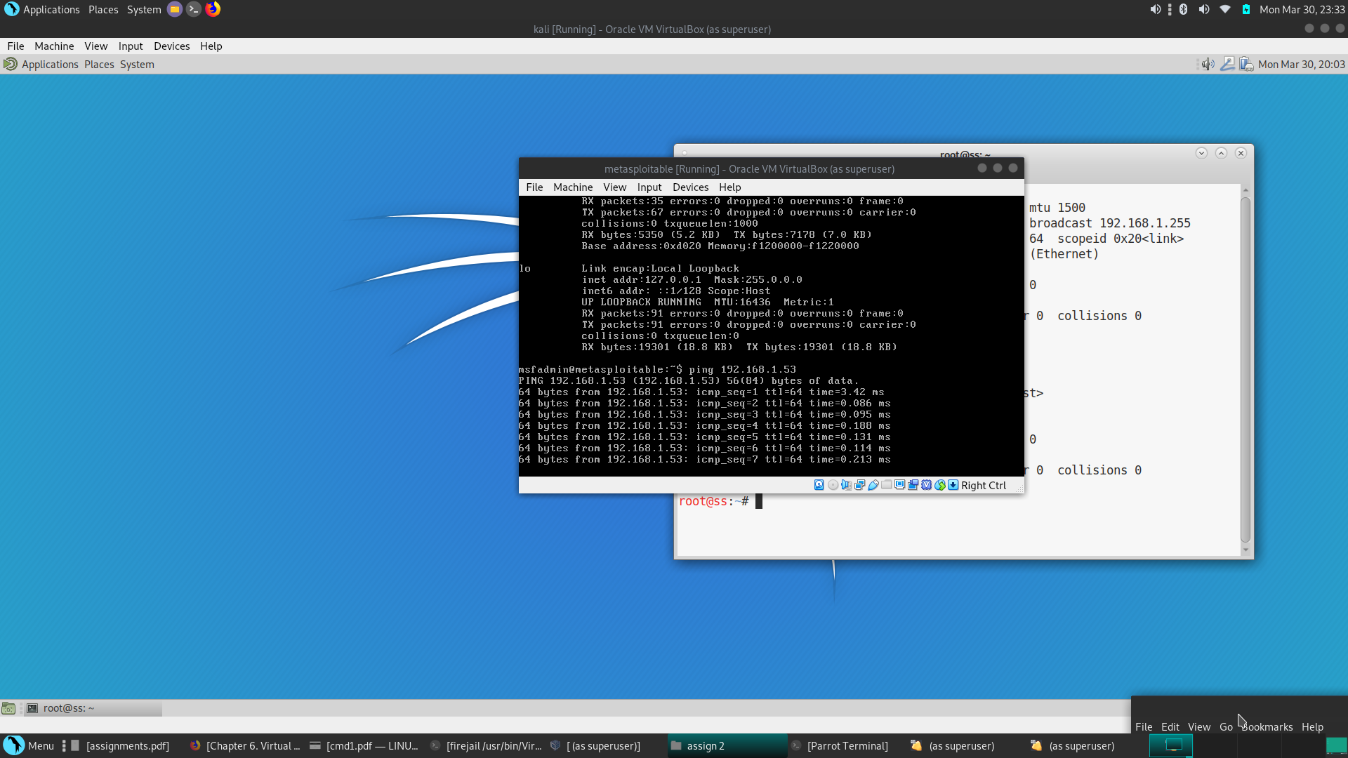

*Figure 4: Kali machine Metasploitable ping in bridge mode*

1.3.2 NAT Snapshots

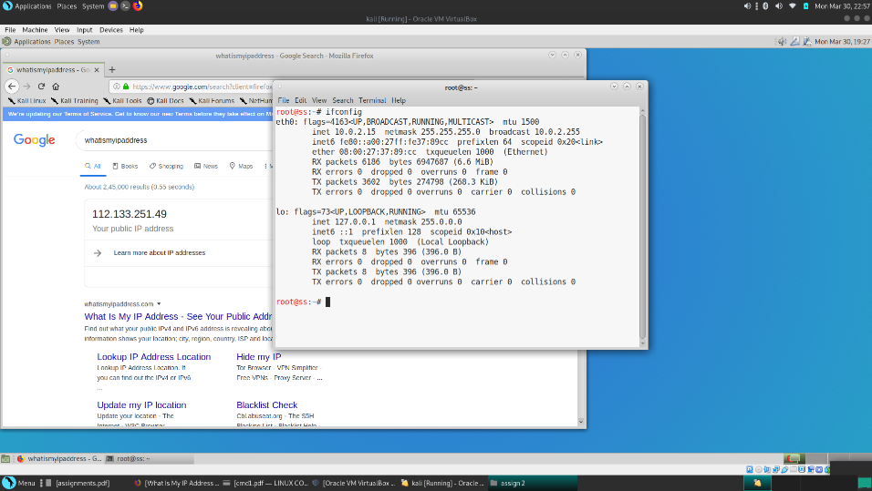

*Figure 5: Kali machine IP in NAT mode*

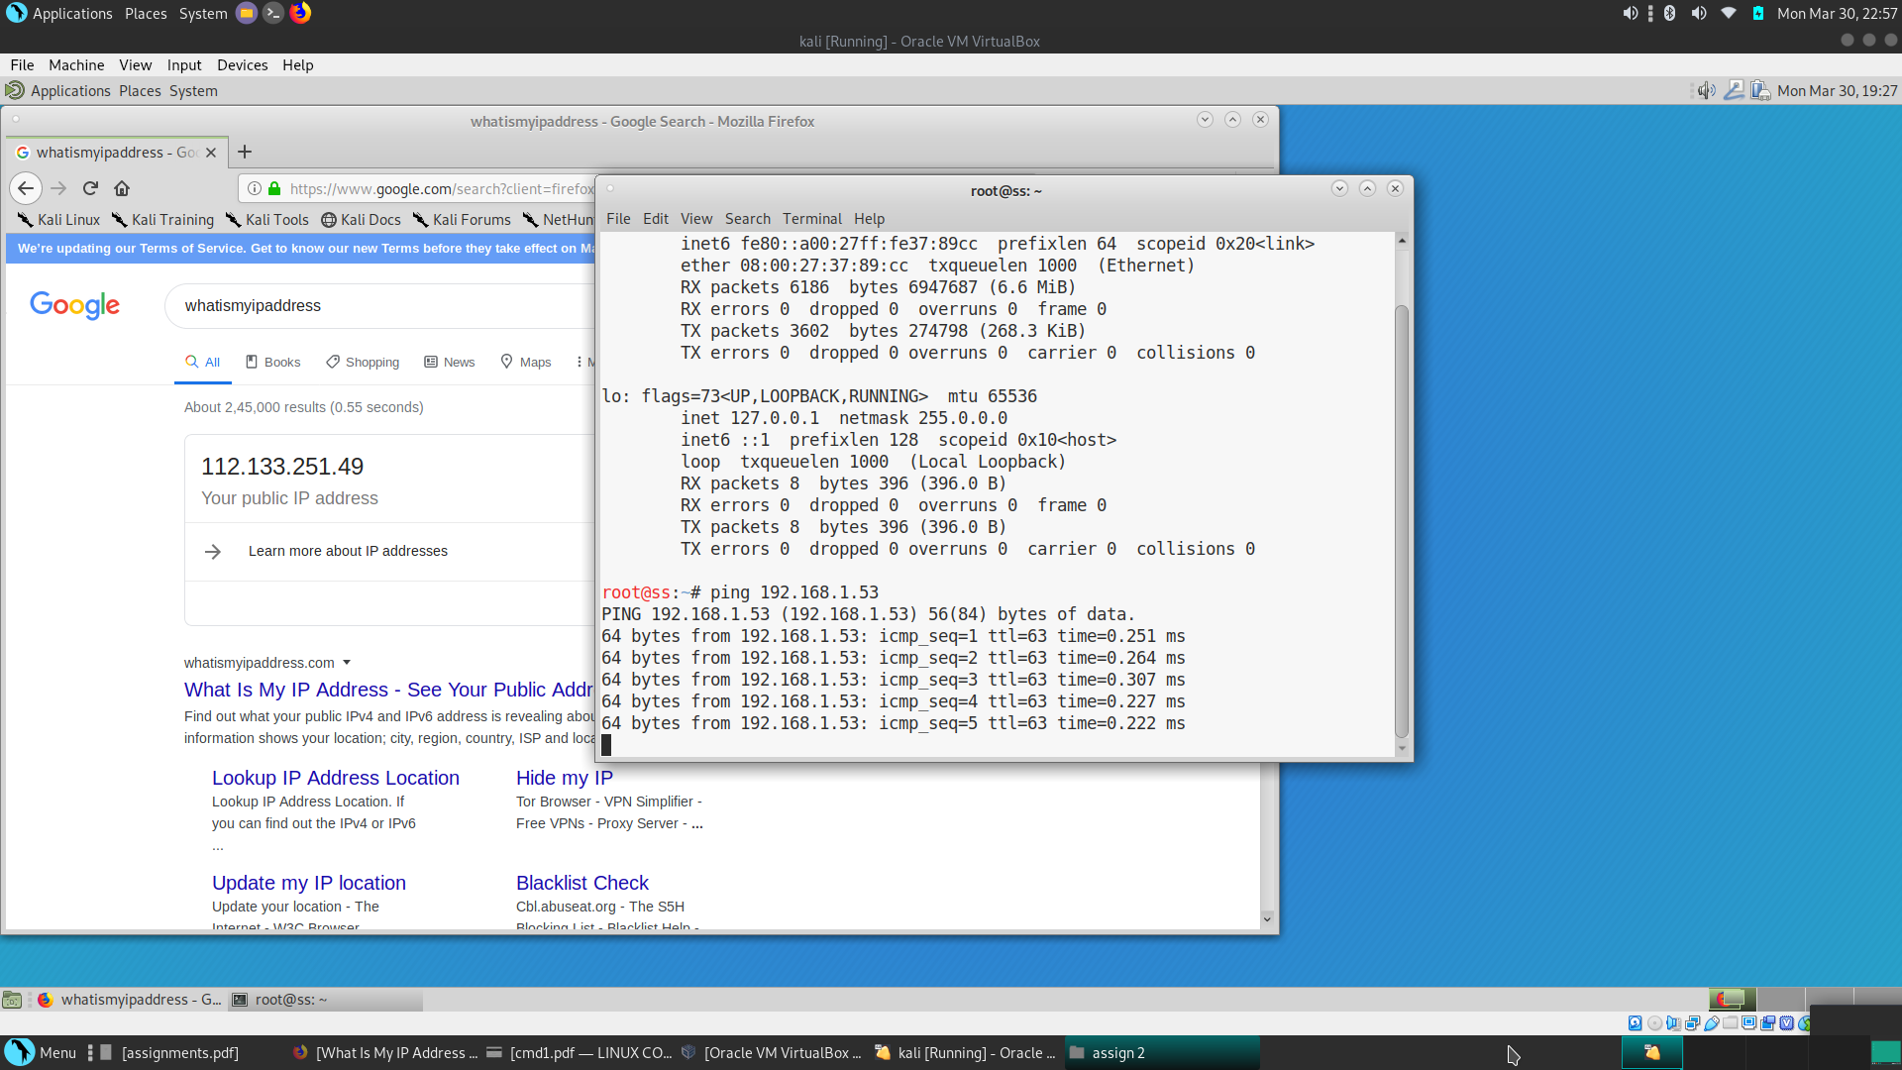

*Figure 6: Kali machine Ping in NAT mode*

1.3.3 Host Only Snapshots

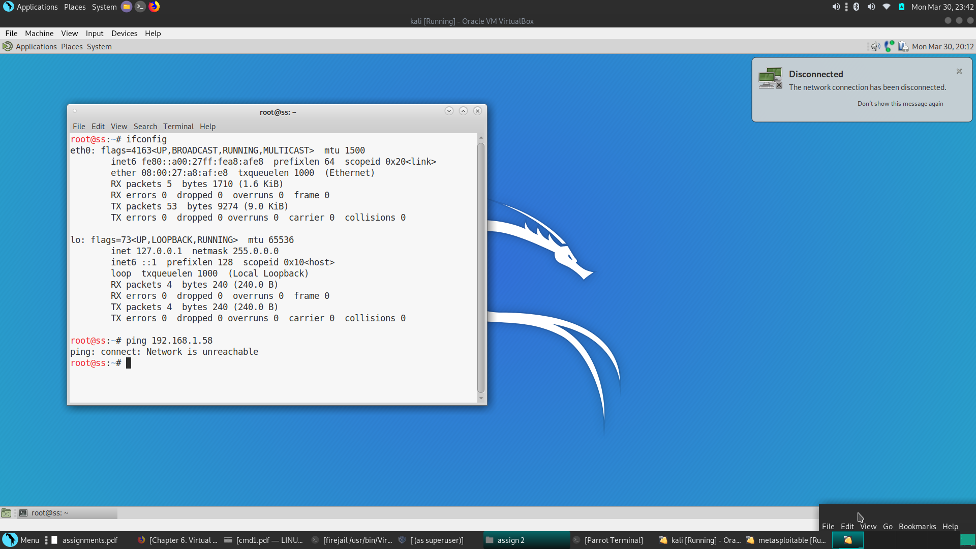

*Figure 6: Kali machine IP in Host Only mode*